Performance Testing
Date | 25/09/2026
Team ID | SWTID-2026-8575
Project Name | AI WeatherWise
Maximum Marks | 5 Marks
Performance Testing
Performance testing evaluates how your system behaves under expected and peak load conditions. Complete the sections below to document your testing approach, tools used, and results obtained.
Step 1: Testing Overview
Field | Details
Testing Tool Used | Thunder Client (Visual Studio Code extension)
Type of Testing | Baseline Response-Time Testing (single user)
Target Module / API | Register (POST /api/auth/register), Login (POST /api/auth/login), Weather (GET /api/weather/chennai) and AI Recommendation (POST /api/ai/weather-recommendation)
Test Environment | Local (Node.js server on http://localhost:5001) with MongoDB Atlas cloud database
Test Date | 25/09/2026
Step 2: Test Scenarios
S.No | Test Scenario / Description | No. of Virtual Users | Duration (sec) | Expected Outcome
1 | User registration: POST /api/auth/register with name, email and password | 1 | < 1 | 201 Created with JWT token; response < 2 s
2 | User login: POST /api/auth/login with valid credentials | 1 | < 1 | 200 OK with JWT token; response < 2 s
3 | Weather data: GET /api/weather/chennai | 1 | < 1 | 200 OK with city weather data; response < 2 s
4 | AI recommendation: POST /api/ai/weather-recommendation with temperature and condition | 1 | < 1 | 200 OK with recommendation; Max < 5 s
Step 3: Performance Test Results
S.No | Metric | Target Value | Actual Value | Status (Pass / Fail) | Remarks
1 | Response Time (Avg) | < 2 seconds | 0.48 s (478 ms) | Pass | Average of the 4 API calls (187, 127, 900, 697 ms)
2 | Response Time (Max) | < 5 seconds | 0.90 s (900 ms) | Pass | Slowest call: Weather API
3 | Throughput (Req/sec) |  | Not measured | - | Single-user run
4 | Error Rate | < 1% | 0% | Pass | 4 of 4 requests succeeded (201 / 200)
5 | CPU Utilization | < 80% | Not measured | - | -
6 | Memory Utilization | < 80% | Not measured | - | -
Step 4: Observations & Analysis
Key Findings:
All four endpoints responded successfully (201 Created and 200 OK) within 1 second, well inside the 2 second average and 5 second maximum targets. Login was the fastest call at 127 ms and the Weather API was the slowest at 900 ms. No request failed, so the error rate was 0%.
Bottlenecks Identified:
The Weather API (900 ms) and the AI Recommendation API (697 ms) were the slowest, as they depend on external services. No bottleneck was found in authentication or database access. These figures come from a single-user run; behaviour under many concurrent users was not measured.
Optimization Steps Taken:
None were needed, since every measured value met its target. Caching recent weather results per city would be a useful future improvement.
Step 5: Screenshots / Evidence
Attach screenshots of your performance testing tool results below (Thunder Client results for each API):
Screenshot 1: Register API - 201 Created, 187 ms
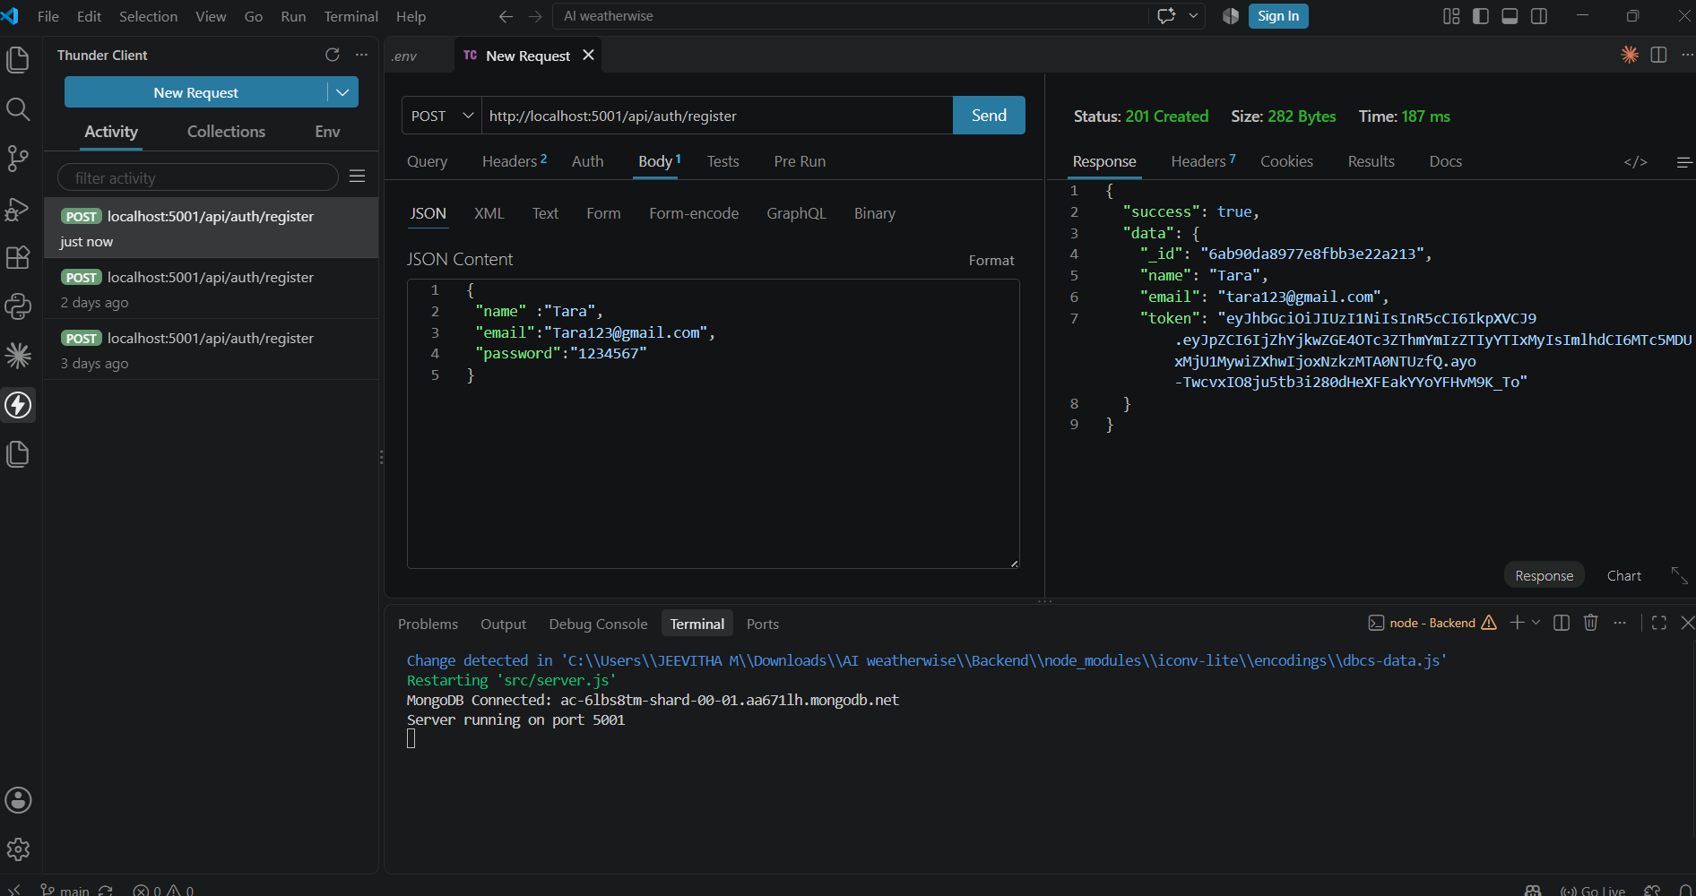

Screenshot 2: Login API - 200 OK, 127 ms
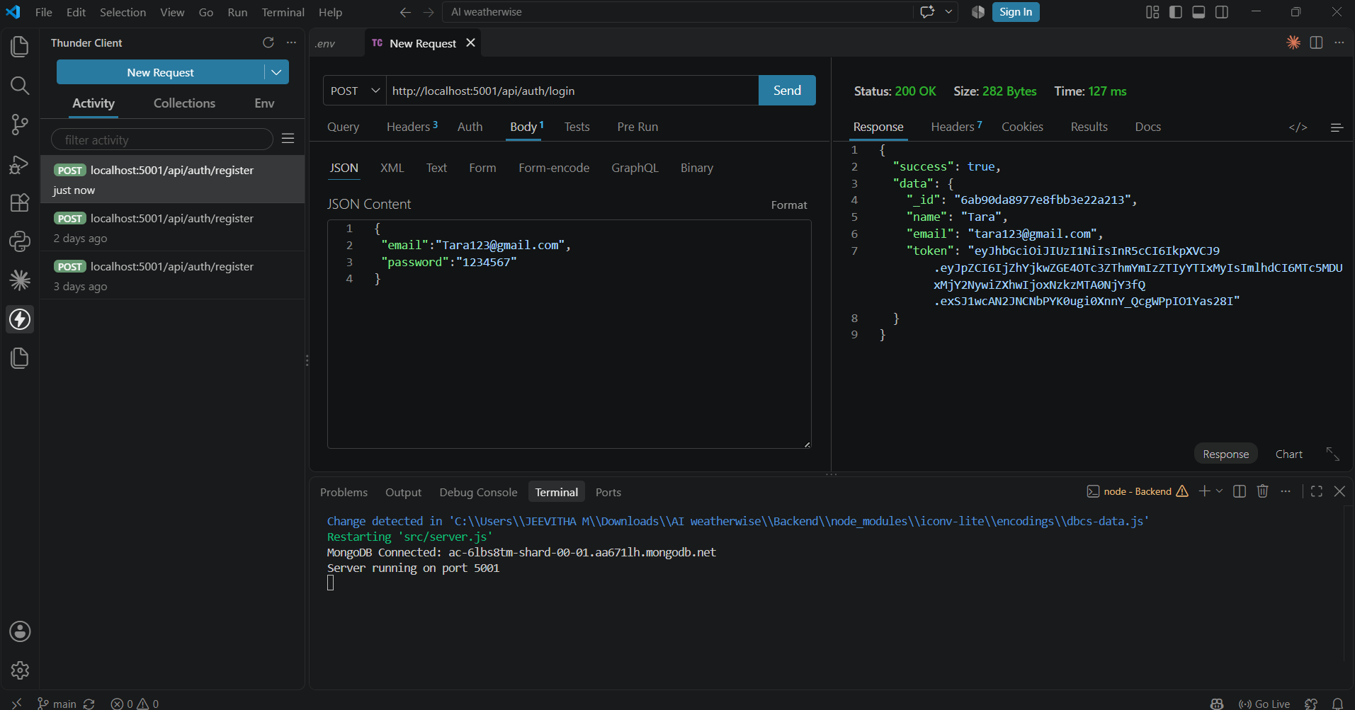

Screenshot 3: Weather API - 200 OK, 900 ms
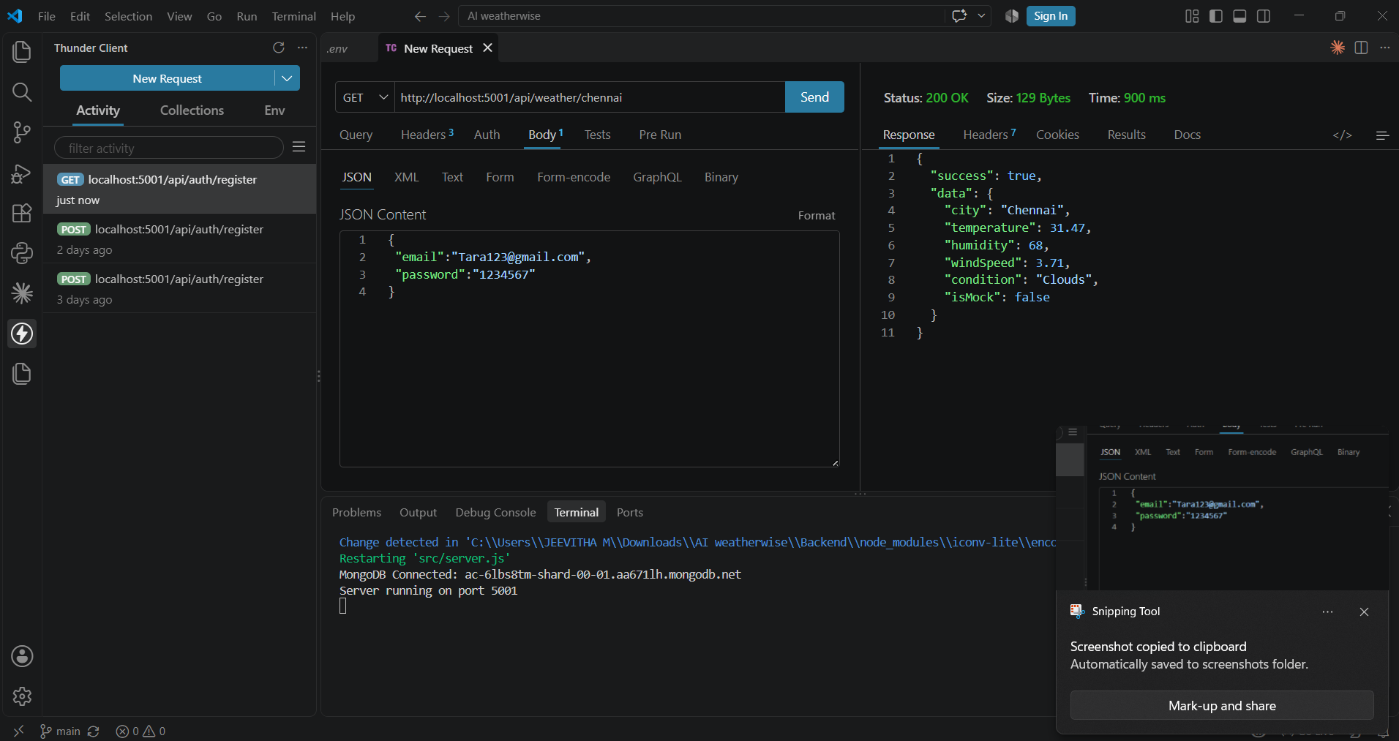

Screenshot 4: AI Recommendation API - 200 OK, 697 ms
